EXP 1- Simulation and Comparative Analysis of FDMA, TDMA and CDMA: Resource Allocation, User Capacity and Mobile-Generation Context
Aim:
To simulate and compare the basic resource-allocation methods used in FDMA, TDMA and CDMA, and examine how their assumed user capacity and interference behaviour differ.
Objectives:
1. Model how FDMA, TDMA and CDMA allocate communication resources among users.
2. Estimate and compare user capacity under stated assumptions.
3. Plot how estimated CDMA SIR changes as the number of simultaneous users increases.
4. Relate the access methods to representative mobile generations and interpret the limits of the simplified model.
Procedure:
1. Run the MATLAB program below.
2. Record the assumed bandwidth, channel width, number of TDMA slots, CDMA processing gain and target SIR.
3. Inspect the printed capacity table and the capacity and CDMA-SIR plots.
4. Inspect the generation comparison table and the conceptual time-frequency resource diagrams.
5. Change at least one parameter for each access method and rerun the program.
6. Compare the new and baseline results; explain the impact of the changed assumptions.
OBJECTIVE 1: To estimate and compare the illustrative number of users supported by FDMA, TDMA and CDMA using the specified system parameters.
PROGRAM:
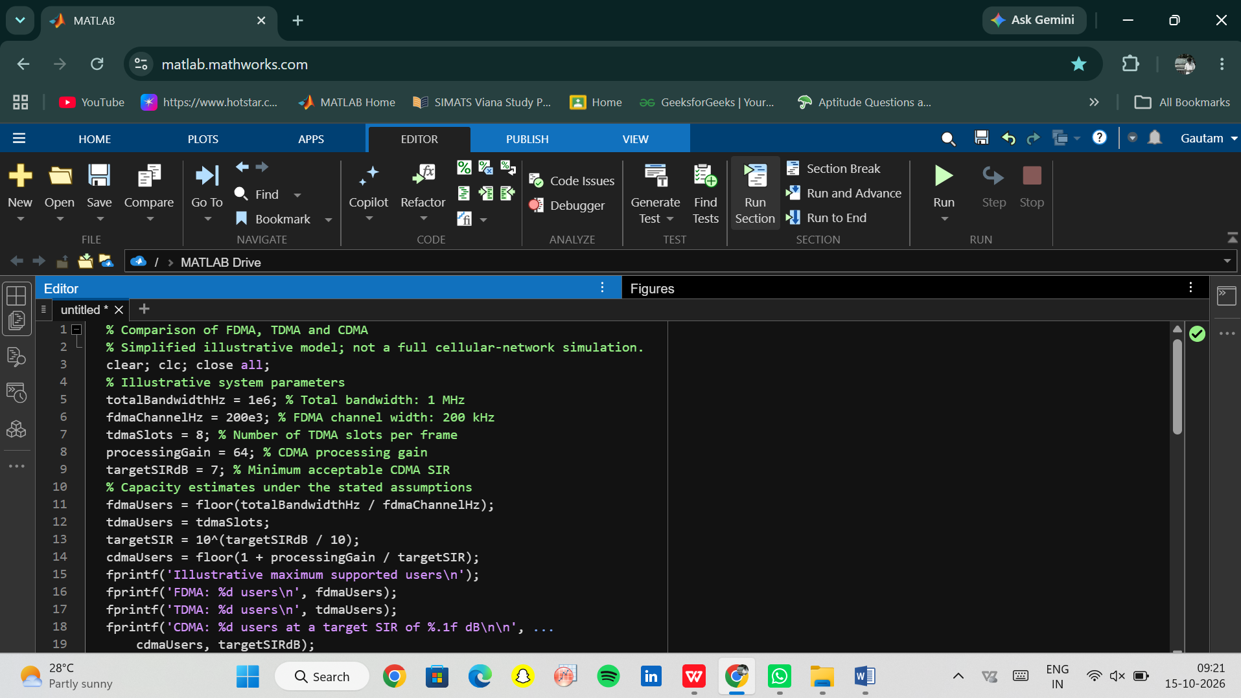
OUTPUT:
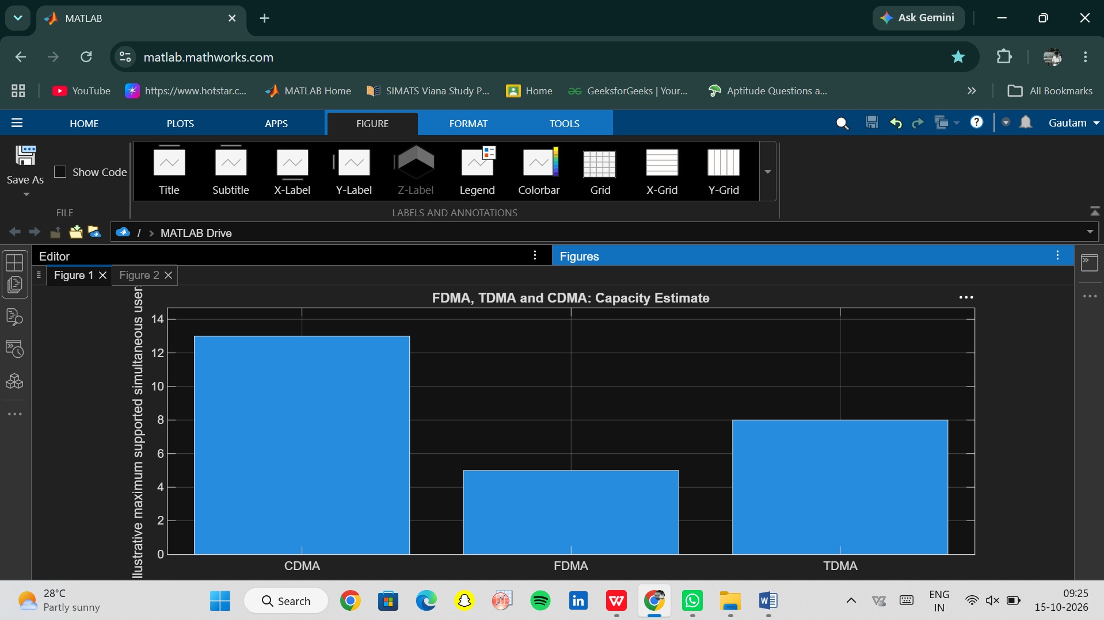

OBJECTIVE 2: To analyze how the estimated CDMA signal-to-interference ratio changes as the number of simultaneous users increases.
PROGRAM:
OUTPUT:
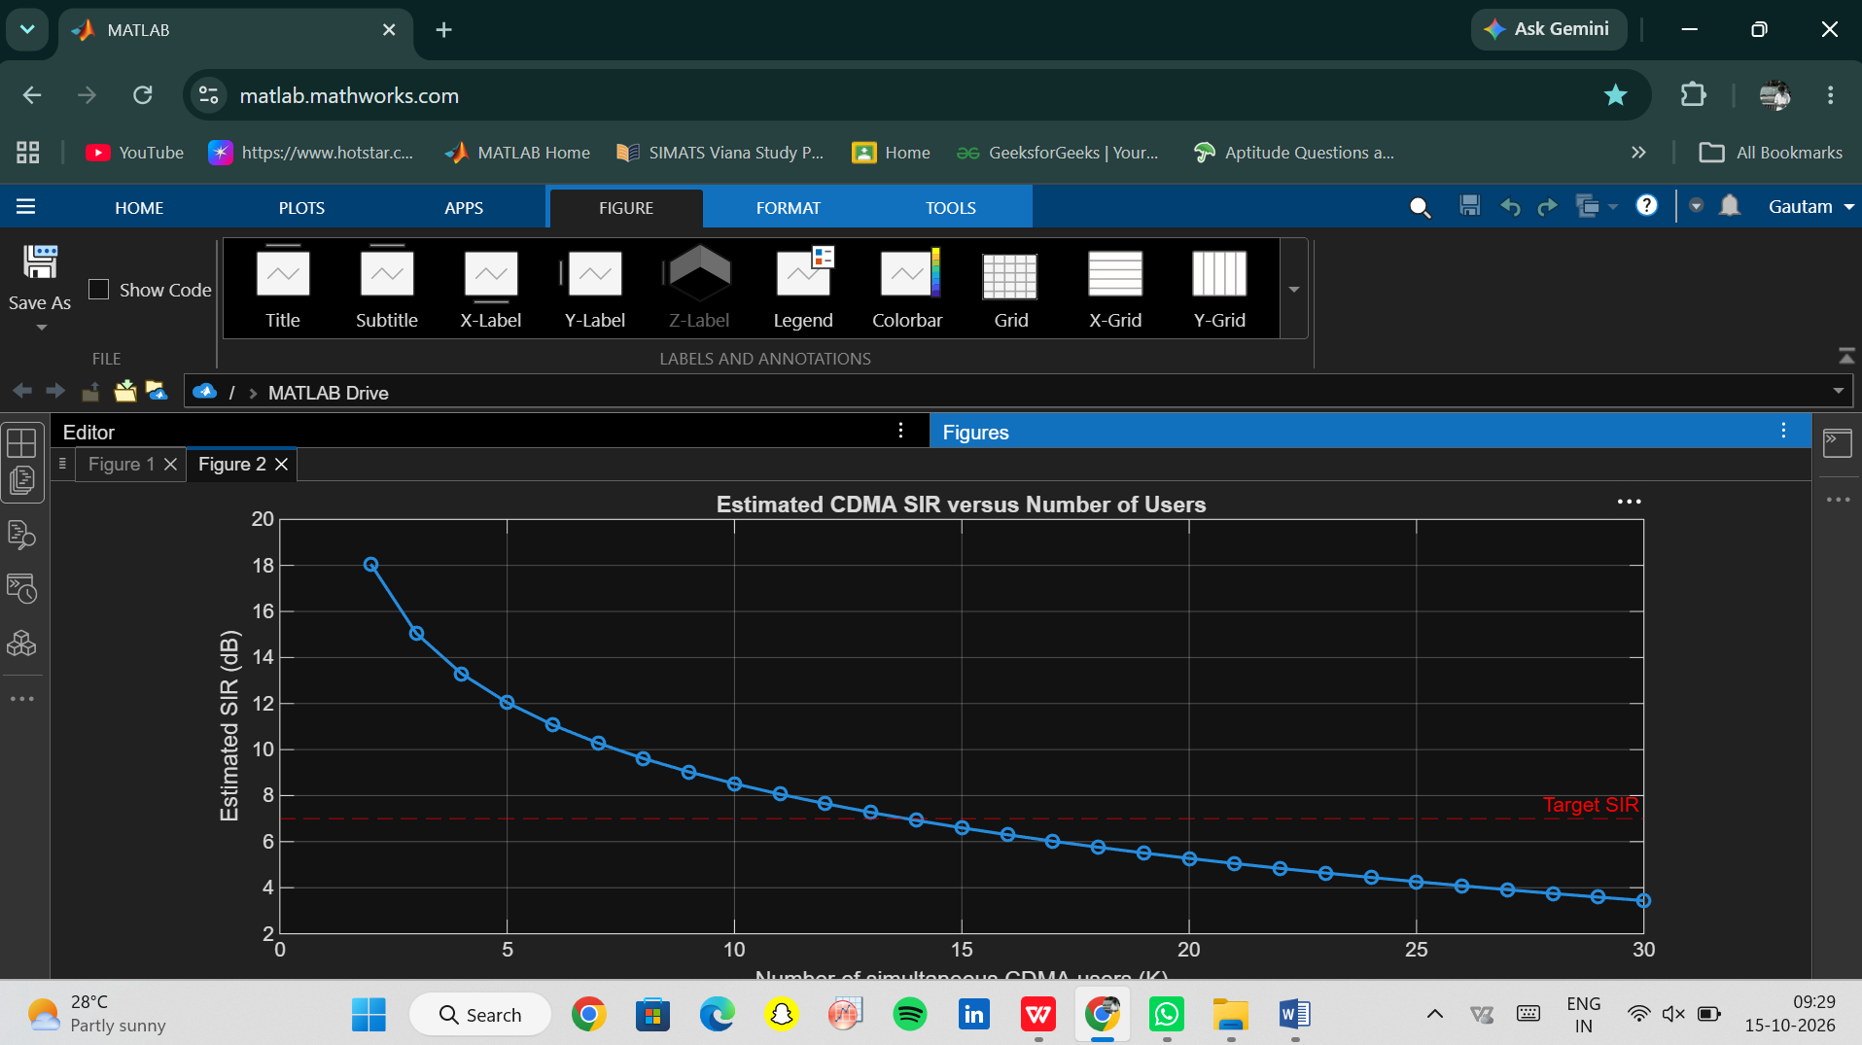
OBJECTIVE 3: To relate representative multiple-access techniques to the evolution of mobile communication systems from 1G to 5G.
PROGRAM:
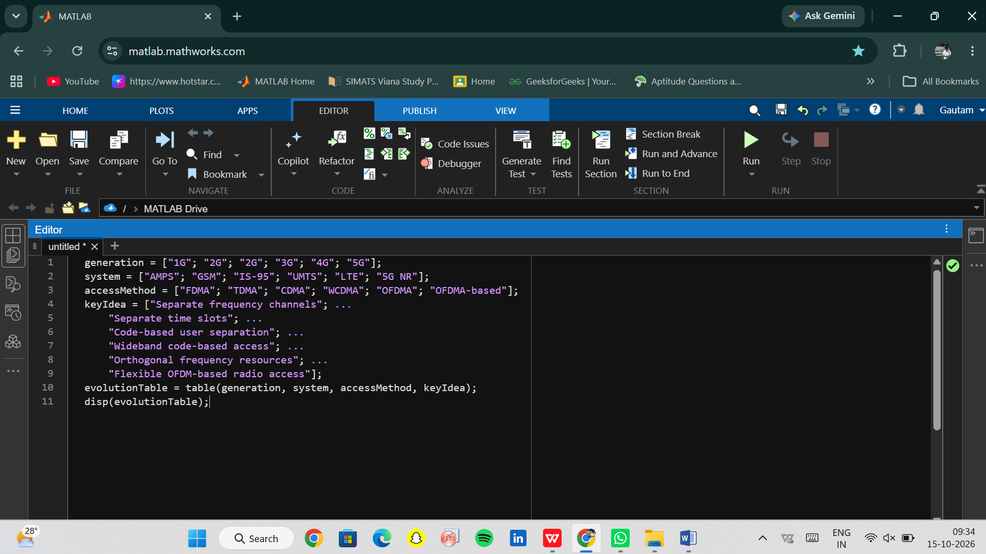
OUTPUT:
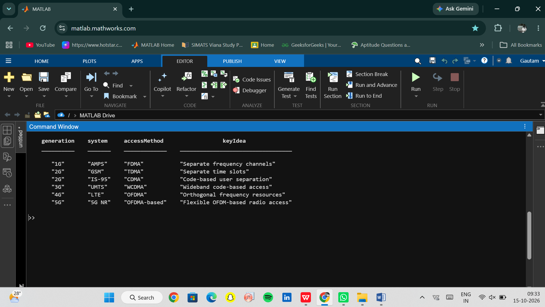
OBJECTIVE 3: To visualize how FDMA, TDMA and CDMA assign frequency, time and code resources to multiple users.
PROGRAM:
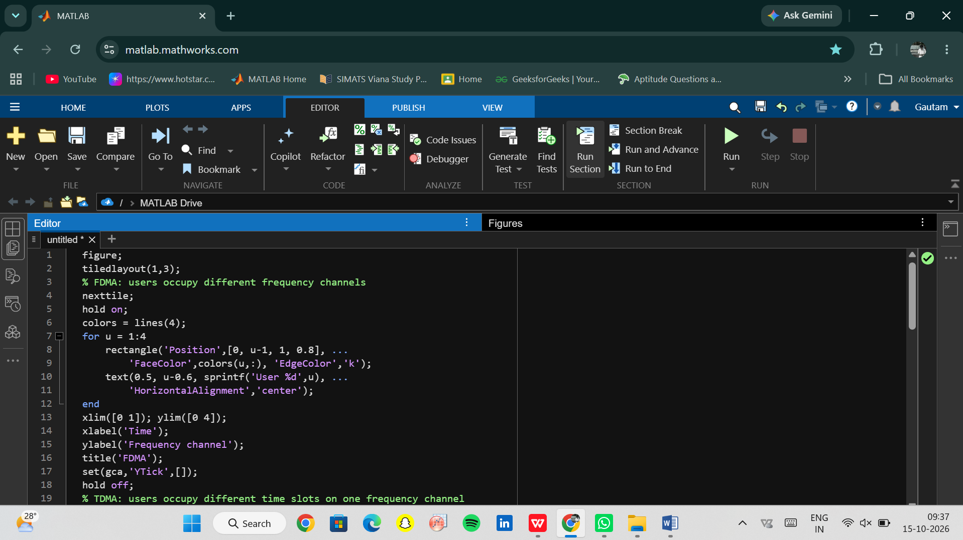
OUTPUT:
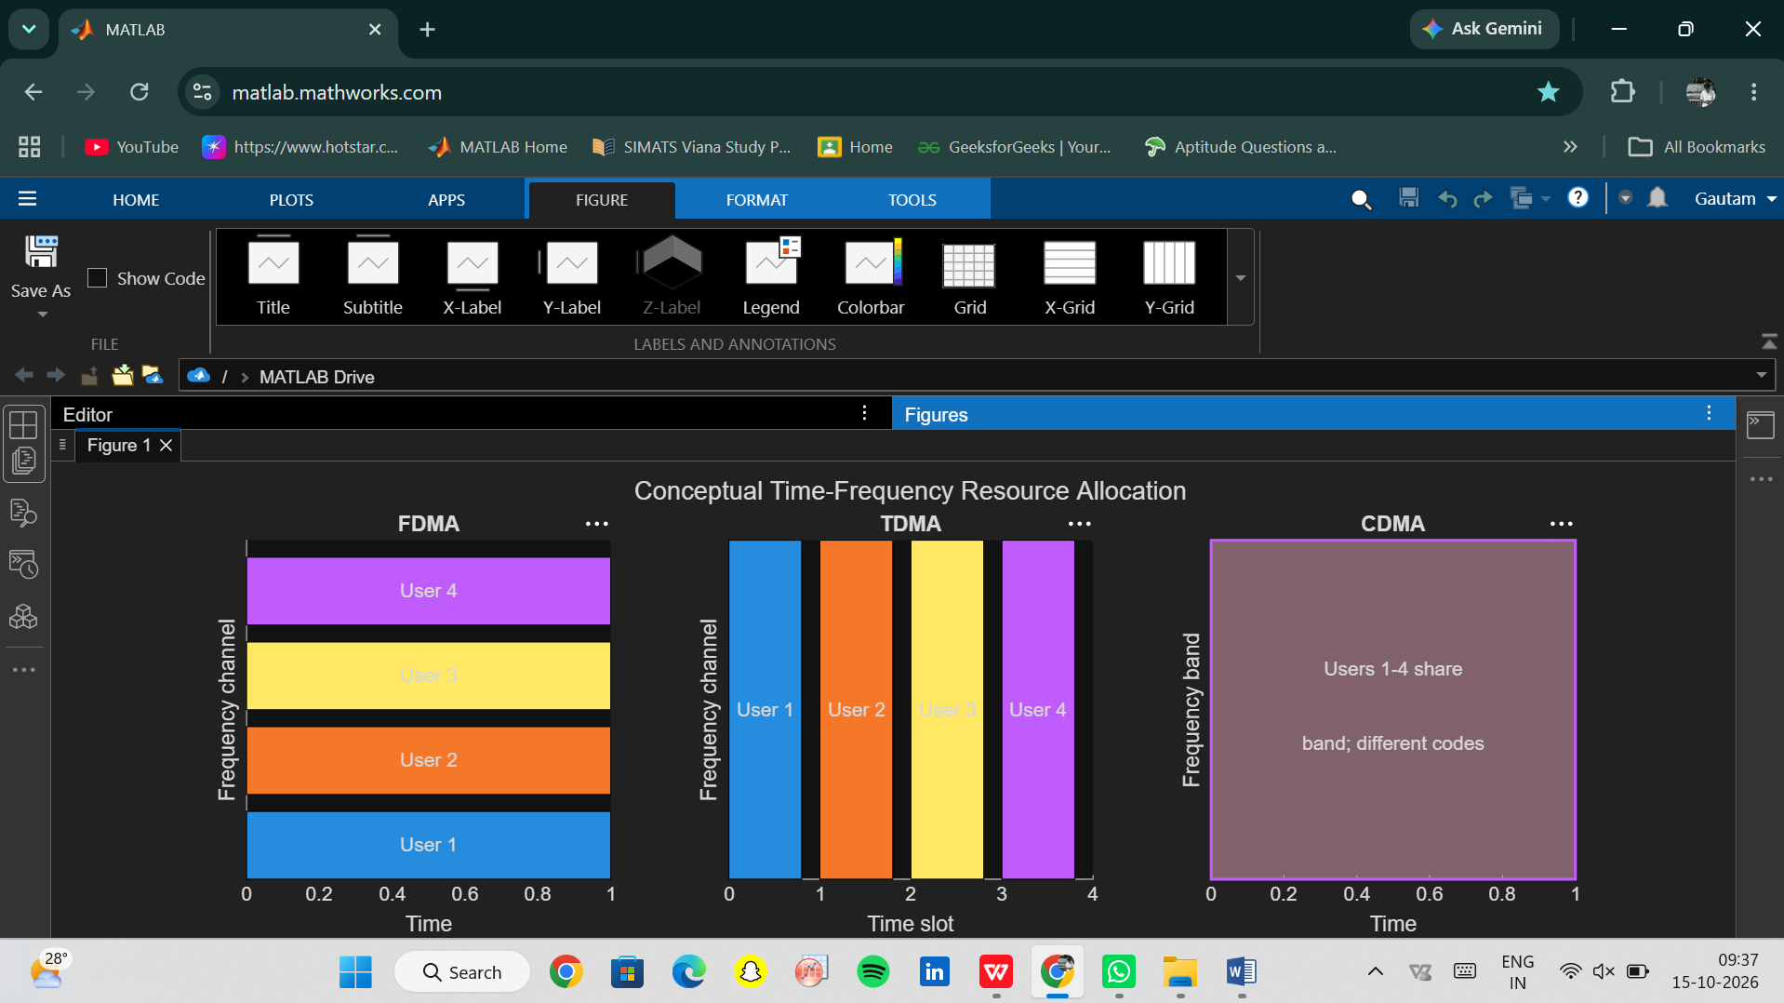
Conclusion:
The four MATLAB programs demonstrate how FDMA, TDMA and CDMA allocate communication resources and how the assumed parameters affect their estimated user capacity. The CDMA analysis shows that estimated SIR decreases as more users share the same frequency band. The mobile-generation table and resource-allocation diagrams connect these techniques to the development of wireless communication systems.These results are based on simplified assumptions. In particular, the model assumes ideal FDMA and TDMA separation and does not include real-world effects such as fading, power control, adjacent-channel interference or guard intervals. Therefore, the results illustrate the operating principles; they should not be treated as a universal performance ranking of the three methods.

